Contemporary Hymnody
WELS National Conference on Lutheran Leadership
Chicago, IL
January 2026

- We Need Contemporary Hymnody
Because the church yearns to express its theology and piety as it lives within time and space.
- Philippians 2
- 301 – “Savior of the Nations Come”
- 863 – “A Mighty Fortress”
- 597 – “Now Thank We All Our God”
- 879 – “Though All Our Life Is Like a Scroll”
Because music is always changing - sometimes for the good, sometimes for the not-so-good. Musicians must, therefore, wrestle with new musical styles.
Example: J. S. Bach, “Savior of the Nations, Come” BWV 61
The church will always be picking and panning as we move forward.
- ? > 15,000 > 4,800 > 980 > 658
- See Appendix 1 (p. 13) for Pastor Jon Bauer’s article, “Searching for Modern Music for the New Hymnal”

You should NOT do contemporary hymnody if…

You SHOULD do contemporary hymnody if…

“How we sing, what we sing, what we keep, and what we leave out are shaping the faith we hand on to the next generation and the musical heritage they will have.”

- Contemporary Hymnody as a Contemporary Reaction
Keith Getty: Modern worship mov't is 'utterly dangerous,' causing 'de–Christianizing of God’s people'
By Leah MarieAnn Klett, Assistant \ Saturday, November 09, 2019
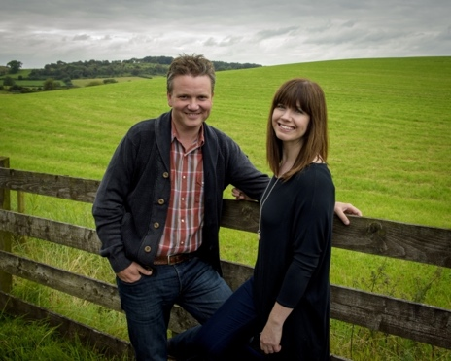
“In Christ Alone” writer Keith Getty is warning church leaders about the modern worship movement, which he describes as one of “cultural relevance” that is “utterly dangerous” and is contributing to the “de-Christianizing of God’s people.”
In an interview with The Christian Post, Getty said many modern worship songs focus on emotionalism rather than sound doctrine and Scriptural truths. This, he said, leads to a generation ill-equipped to understand or defend the Christian faith.
“An authentic generation doesn’t begin with catharsis; it has to begin with an authentic picture of the God of the Bible,” he explained. “Over 75 percent of what are called the great hymns of the faith talk about eternity, Heaven, Hell, and the fact that we have peace with God. Yet, less than 5 percent of modern worship songs talk about eternity.”
“Many worship songs are focused on this Earth,” Getty said. “I believe that the modern worship movement is a movement for cultural relevance. It’s a de-Christianizing of God’s people. It’s utterly dangerous. I have no quibbles saying, ‘Enough is enough.’ This can’t happen to build an authentic generation.”
Keith Getty and his wife, Kristyn, are passionate about fostering a “reformation” in worship music: “Part of our campaign is to get our generation to know the great hymns of the faith,” Getty told CP. “It’s not about a fascination with the time period; it’s about writing music that explains the Gospel and is also beautiful art."
“Beautiful art lasts," he said. "At the end of the day, a song you sing for 50 years is more valuable than one you sing for 50 months. We live in the most exciting generation to be a Christian, but it’s also the most challenging generation. This idea that Christianity is cool or easy is not biblical. It’s a misnomer for our generation. Through music, we want to build deep believers who know and love Christ….”
Three years ago, the Gettys — who this year won a Dove Award for Inspirational Album of the Year — launched the Sing! Conference to bring together worship leaders, pastors, and those involved in church music ministry to explore together the connection between music, theology, and artistry.
Now, the Sing! Conference is a global movement. This year, the couple hosted sell-out Sing! conferences at the Belfast arena in their native Northern Ireland, and another at Edinburgh's Usher Hall, marking the launch of the first Sing! global arena tour.
In August, the Sing! Conference in Nashville featured speakers John Piper, Joni Eareckson Tada, along with musical performances by the Gettys, Ellie Holcomb, and Trip Lee, among others. The three-day event saw over 13,000 attendees, nearly half of whom were younger than 40 years old.
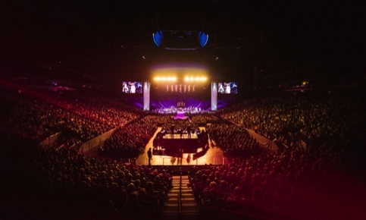
“We think, after this year, with the number of universities getting involved, the Sing! Conference will be a majority under 40s conference,” Getty said. “There are 82 church music conferences in America and this is the largest. And this is the only one that doesn’t work with contemporary radio. We don’t use the lights-camera-action stuff of the previous generation. We’ve dumped all of that, yet we’re getting more under 40s of any church music conference.”
The success of the Sing! Conference with millennials, the songwriter noted, indicates younger generations are “less convinced by the seeker-sensitive purpose-driven hype of making Christianity seem cool.”
Over 13,000 people gathered for a night of praise and worship led by Keith and Kristyn Getty at Bridgeston Arena in Nashville, Tennessee, on Aug. 20, 2019. | Sing! Conference
“They want to know, ‘is this true or not?’” he contended. “People think this conference is conservative and on one level it is, but on another level, the range of denominations attending is pretty broad. They’re all terrified of what the next generation is singing and don’t know what to do.”
“We don’t know all the answers,” Getty added, “but we’re trying to get people to sing doctrine and get hymn writers that are writing high-quality music with artistic merit.”

- Contemporary Hymnody in Our WELS Context
Definition of a Hymn:
“A metrical poem offered to God in worship, which is intended for congregational use; it springs out of the life of devotion as an expression of faith, and it gains its usage as much by the tune which is used as by the sentiments expressed in the text.”
Caveat:
“Any treatment of the hymn which ignores any of these elements removes the hymn from its actual usage and is, to that degree, limited. For this reason, it is extremely difficult to set down rigorous standards by which the excellence of a hymn may be judged.”
Sample of a praise song:

I love You, Lord
For Your mercy never fails me
All my days, I've been held in Your hands
From the moment that I wake up
Until I lay my head
Oh, I will sing of the goodness of God
'Cause all my life You have been faithful
And all my life You have been so, so good
With every breath that I am able
Oh, I will sing of the goodness of God.
I love Your voice
You have led me through the fire
In darkest night You are close like no other
I've known You as a Father
I've known You as a Friend
And I have lived in the goodness of God, yeah.
Refrain
Your goodness is running after, it's running after me
With my life laid down, I surrendered now
I give You everything, oh Lord (x2)
Refrain
Songwriters: Ben Fielding / Brian Johnson / Edward Martin Cash / Jason Ingram / Jenn Johnson Goodness of God lyrics © Capitol CMG Publishing

Sample of a hymn:

- In Christ alone my hope is found;
he is my light, my strength, my song;
this cornerstone, this solid ground,
firm through the fiercest drought and storm.
What heights of love, what depths of peace,
when fears are stilled, when strivings cease!
My comforter, my all in all;
here in the love of Christ I stand.

2 In Christ alone, who took on flesh,
fullness of God in helpless babe;
this gift of love and righteousness,
scorned by the ones he came to save.
Till on that cross as Jesus died,
the wrath of God was satisfied;
for ev’ry sin on him was laid;
here in the death of Christ I live.

Text: Stuart Townend, b. 1963; Keith Getty, b. 1974
Text: © 2002 Thankyou Music, admin. CapitolCMGPublishing,com. Used by permission: OneLicense no. 714730

Words have meaning:
“In 2010, the Celebrating Grace hymnal altered a lyric in Keith Getty and Stuart Townend’s “In Christ Alone.” The hymnal editors changed the line “Till on that cross as Jesus died, the wrath of God was satisfied,” to read, “Till on that cross as Jesus died, the love of God was magnified.” Since the editorial team did not receive consent to the lyric change, they reinstated the original wording in 2013 and subsequent printings. Later hymnals, including the Presbyterian Church U.S.A.’s Glory to God (2013), did not include the hymn because some hymnal committees deemed the song to contain questionable theology.
Should believers sing about God’s wrath in worship? Yes, because it is intrinsically connected to God’s righteousness and our redemption. God’s wrath is a redemptive mode of his eternal righteousness, and Jesus satisfied at the cross the wrath of the Triune God that is revealed against sinners to provide the means of salvation. If believers do not sing about God’s wrath, their understanding of salvation and gratitude for redemption will remain incomplete.”

Criterion for picking hymns in Christian Worship 2021:
- Christocentric
812 – “Christ, the Sure and Steady Anchor” (Matt Boswell/Matt Papa)
- In harmony with the scriptural faith as confessed in the Lutheran Book of Concord. (Especially, but not restricted to, means of grace focus, justification-centered, law/gospel dichotomy, receptive view of worship, proclamatory/didactic function of hymnody, etc.)
568 – “His Robes for Mine” (Chris Anderson/Greg Habegger)
- Rooted in the Church year with its emphases on the life of Christ and the Christian’s life in Christ
877 – “Reformation Song” (Tim Chester/Bob Kauflin)
385 – “Christ Begins” (Luke Thompson/Kent Reeder)
- Drawn from classic Lutheran sources and deliberately inclusive of the Church’s broader song (including so-called International or Global music)
851 – “Now Calm Your Heart” (Nicklaus Herman/Jeremy S. Bakken)
- Superlative examples of their genre in regard to both textual content and musical craft
“I Will Wait for You” (Psalm 130G) (Stuart Townend/Keith Getty/Jordan Kauflin/Matthew Merker))
- Accessible and meaningful for God’s people at worship in both public and private settings
600 – “All Praise to Him” (Bob Kauflin/Matt Merker)

- Useful for those who preach and teach the faith
815 – “I Look not Back” (Mike Schultz)
- Parts of a corpus that will find wide acceptance by the vast majority of our fellowship
580 – “All I Have Is Christ” (Jordan Kauflin)
Application:
There are more than 60 contemporary hymns in CW21. Significant work has been done for you! Don’t feel the need to be your own hymn committee. Don’t assume that if it has been done in a WELS church, then it should be done in your WELS church. See Appendix 2 on p. 17 for a list of contemporary hymns available in Christian Worship: Hymnal (2021).
Look to the “lyrical psalms” for modern psalmody options. The index of “Genres and Musical Styles” on pages 832–33 in Christian Worship: Psalter is indispensable for worship planning.

- Variety within the CW Family
New texts/translations for familiar tunes
611 – “Joyously I’ll Praise My Savior”
New tunes for familiar texts
844, 845 or Getty/Merker? – “What God Ordains is Good and Right”
Same tunes with new musical settings
826 – VON GOTT WILL ICH NICHT LASSEN
544 – I AM THE BREAD OF LIFE
544 – I AM THE BREAD
839 – TOPLADY
Application:
Traditional hymns can live and thrive in modern musical idioms. Do them. This is, perhaps, the musical experiment of our generation. (Think of Koine, Branches Band, etc.)
The metrical index of tunes (pp. 970–978) is indispensable for service planning.
- Hymns Outside of the CW Family Require Careful Discernment
Sobriety is needed for the search:
“Contemporary worship music hymns not only were/are comparatively poor; they had to be. One generation cannot successfully “compete” with 50 generations of hymn-writers; such a generation would need to be fifty times as talented as all previous generations to do so. If only one-half of one percent (42 out of over 6,500) of Charles Wesley’s hymns made it even into the Methodist hymnal, it would be hubristic/arrogant to think that any contemporary hymnist is substantially better than he. Most hymnals are constituted of hymns written by people with Wesley’s unusual talent; the editors had the “pick of the litter” of almost two thousand years of hymn-writing. In English hymnals, for instance, we rarely find even ten of Paul Gerhardt’s 140 hymns, even though many musicologists regard him as one of Germany’s finest hymnwriters. Good hymnals contain, essentially, “the best of the best,” the best hymns of the best hymnwriters of all time; how could any single generation compete with that?
Just speaking arithmetically, one would expect that, at best, each generation could represent itself as well as other generations, permitting hymnal editors to continue to select “the best of the best” from each generation. Were this the case, then one of every fifty hymns we sing should be from one of the fifty generations since the apostles, and, therefore, one of every fifty should be contemporary, the best of the current generation of hymnwriters. Perhaps this is what John Frame meant when, in the second paragraph of his book on CWM, he indicated that he had two goals for his book: to explain some aspects of CWM and to defend its “limited use” in public worship. Perhaps Prof. Frame thought one out of fifty constituted “limited use,” or perhaps he might have permitted as much as one out of ten, I don’t know. But our generation of hymnwriters, while talented and devout, are not more talented or more devout than all other generations, and are surely not so by a ratio of fifty-to-one.”

Two tools that assist with discernment:
1. Text, Music, Context: A Resource for Reviewing Worship Materials (Appendix 3, p. 21)
- Text: “Battle Hymn of the Republic”
Mine eyes have seen the glory of the coming of the Lord
He is trampling out the vintage where the grapes of wrath are stored
He hath loosed the fateful lightning of His terrible swift sword
His truth is marching on
Glory, Glory, hallelujah!
Glory, glory, hallelujah!
Glory, glory, hallelujah!
His truth is marching on.
I have seen Him in the watch-fires of a hundred circling camps
They have builded Him an altar in the evening dews and damps
I can read His righteous sentence by the dim and flaring lamps
His day is marching on.
I have read a fiery gospel writ in burnished rows of steel
"As ye deal with my contemners, so with you my grace shall deal"
Let the Hero, born of woman, crush the serpent with his heel
Since God is marching on
He has sounded forth the trumpet that shall never call retreat
He is sifting out the hearts of men before His judgment-seat
Oh, be swift, my soul, to answer Him! Be jubilant, my feet!
Our God is marching on
In the beauty of the lilies Christ was born across the sea
With a glory in His bosom that transfigures you and me
As He died to make men holy, let us die to make men free
While God is marching on.

- Melody: “Absent from the Flesh” by Sojourn

Absent from flesh, O blissful thought
What joy that moment brings
Freed from the blame my sin has brought
From pain and death and its sting
Absent from flesh, O glorious day!
In one triumphant stroke
My reckoning paid, my charges dropped
And the bonds 'round my hands are broke
I go where God and glory shine
To one eternal day
And this failing body I now resign
For the Angels point my way
For the Angels point my way
Absent from flesh! Then rise, my soul
Where feet nor wings could climb
Beyond the sky, where planets roll
And beyond all keep of time
Refrain
Absent from flesh! Then see thy God
With eyes unveiled and free
We'll face to face His glory laud
And radiance ever see
Refrain

- Context: = Where is the theological “center of gravity” in your service?

- 2. Praise Song Cruncher (Appendix 4, p. 26) “Goodness of God” by Bethel Music

I love You, Lord
For Your mercy never fails me
All my days, I've been held in Your hands
From the moment that I wake up
Until I lay my head
Oh, I will sing of the goodness of God
'Cause all my life You have been faithful
And all my life You have been so, so good
With every breath that I am able
Oh, I will sing of the goodness of God.
I love Your voice
You have led me through the fire
In darkest night You are close like no other
I've known You as a Father
I've known You as a Friend
And I have lived in the goodness of God, yeah.
Refrain
Your goodness is running after, it's running after me
With my life laid down, I surrendered now
I give You everything, oh Lord (x2)
Refrain

- Issues in Performing Contemporary Hymnody
Exercise care in your use of videos and recorded materials. Let the people participate!
“Irreducible complexity” = What is the bare minimum that this hymn requires for a convincing performance?
Example: “O Lord, How Shall I Meet You”
Miscellaneous performance issues:
All music is (at times) loud, and should be
“There should be no doubt that, in the gathering of God’s people, there’s an appropriate time for loud volume. Gather five hundred souls in a room, get them all singing in harmony, and you’ll see that they can get incredibly loud – and they should be. The psalmist says, “Shout to God with loud songs of joy” (Ps. 47:1).

The difference between bad and loud
“Music that’s described as “too loud” is often more of an issue with harshness than with volume.”
Musicians – “Using their talents” ≠ Good enough to lead worship
Instruments – Doctrine of stewardship applies!
Sound Equipment – More than adequate for the room
Sound Engineers
“The person behind the board can make a good band sound bad, and a bad band sound worse.
Room/Acoustics
“If you’re going to use a rock ensemble in worship, it’s wise to treat the room in such a way that it hinders reflections, absorbing sound in chairs, bodies, floors, and walls.”
NB: This suggestion is at odds with a Lutheran understanding of participation in worship! How to resolve? An “acoustic” sound can thrive in a “live” space without needing to dampen the sound.

Specific Encouragement:
Take 33 minutes to watch the “Worship Led by a Modern Ensemble” module at https://welscongregationalservices.net/worship-led-by-a-modern-ensemble/

- Programming Contemporary Hymnody
Remember the peculiar function of each hymn in the service:
- Opening: Transition/Gathering
- Hymn of the Day: Summarization
- Sermon Hymn: Reflection/Solidification
- Closing Hymn: Transition/Sending
Psalmody
- Metrical psalms (p. 832 in CW: Psalter)
- “Lyric” psalms (p. 833 in CW: Psalter)
Liturgy
- The Service: Settings II, III, and V are through-composed settings of the liturgy designed for organ or liturgical ensemble.
- Metrical versions of The Service are available in Christian Worship: Builder with American, British, German, Scandinavian, and Evening hymn tune settings.
- There are 46 different ways to sing Gloria in Excelsis provided in Christian Worship: Builder. The majority of those lend themselves to accompaniment by a contemporary ensemble.
Sample Service
Proper 13B
- Theme: He removes their fear by his comforting and powerful presence.
- 2 Kings 6:8–17 – Elisha surrounded by Aram in Dothan
- Psalm 46 – The God of Jacob is our refuge
- 2 Timothy 4:6–8, 16–18 – Paul’s farewell
- Mark 6:45–56 – Jesus walks on water to encourage his disciples
Opening Hymn: 917 – “God Himself Is Present”
Gloria: From The Service: Setting VII (British) to HYFRYDOL; Music from hymncharts.com

1 Glory be to God in heaven,
peace to those he loves so well.
On the earth let all his people
speak his grace, his wonders tell:
Lord, we praise you for your glory,
mighty Father, heaven’s King;
hear our joyful adoration
and accept the thanks we bring.
2 Only Son of God the Father,
Lamb who takes our sin away,
now with him in triumph seated—
for your mercy, Lord, we pray:
Jesus Christ, most high and holy,
Savior, you are God alone
in the glory of the Father
with the Spirit, Three in One!

Text: Michael A. Perry
Text: © 1982 Hope Publishing Co. Used by permission: OneLicense no. 714730
Psalm 46: “A Mighty Fortress”
Anthem: 834 – “Still, My Soul, Be Still
Hymn of Day: 803 – “Day by Day”
https://online.nph.net/day-by-day-lead-sheet
Musical Offering: Bach, Organ Sonata #4
Sanctus: From The Service: Setting VI (American) to WEBB; Music from hymncharts.com

1 Sing, “Holy, holy, holy
Lord God of hosts on high,
your everlasting glory
fills earth and sea and sky.”
Our voices cry, “Hosanna!”
Lord, hear our humble plea:
in mercy, come and save us;
in love, come set us free.

2 Hosanna in the highest!
How blest is Christ our King,
who died as our Redeemer,
eternal life to bring!
How blest are you, Lord Jesus,
now coming in God’s name!
“Hosanna in the highest!”
our grateful hearts proclaim.

Text: Michael D. Schultz
Text: © 2021 Northwestern Publishing House. Used by permission: OneLicense no. 714730
Agnus Dei: From The Service: Setting VI (American) to HAMBURG; Music from CW 407

1 O Lamb of God, once lifted high
upon a cross to bleed and die,
in perfect love you took our place—
bestow on us your saving grace.

2 O Lamb of God, your sacrifice
has cancelled sin, has paid its price;
your perfect love will never cease—
have mercy, Lord, and grant us peace.

Text: Michael D. Schultz
Text: © 2021 Northwestern Publishing House. Used by permission: OneLicense no. 714730
Distribution: 662 – “Draw Near”
Closing Hymn: 850 – “When Peace Like a River”

- Resources
WELS Congregational Services video on using a modern ensemble in worship: https://welscongregationalservices.net/worship-led-by-a-modern-ensemble/
Christian Worship: Musician’s Resource https://online.nph.net/musicians-resource
- There are currently 48 hymns fully resourced with accompaniments for a liturgical ensemble. 449 lead sheets are also available. More resources are on the way. The XC’s goal was to fully resource CW21 for modern instrumentation.
Contemporary hymn accompaniments
- Phil Magness’s Hymns for the Contemporary Ensemble, Volumes I and II (CPH)
- Thomas Keesecker’s Sing It Simply, Volumes I and II contain a total of 46 hymn arrangements.
  - https://www.morningstarmusic.com/sing-it-simply-25-congregational-hymn-accompaniments-for-piano-with-opt-guitar-bass-and-handbells.html
  - https://www.morningstarmusic.com/sing-it-simply-volume-ii-21-congregational-hymn-accompaniments.html
- A Hymncharts.com subscription is worth its weight in gold.
- Tony Alonso’s Revival, Revival II, and Revival III (Christmas) at GIA
  - https://giamusic.com/resource/revival-music-collection-print-g9405
  - https://giamusic.com/resource/revival-volume-2-music-collection-print-g9900
  - https://giamusic.com/resource/what-child-is-this-print-g10444

Prof. Aaron Christie
Wisconsin Lutheran Seminary
Mequon, WI
Aaron.christie@wls.edu
414-502-4160

Appendix 1: “Searching for Modern Music for the New Hymnal”
As the hymns committee began its search for the 200 or so new hymns that will be included in the next hymnal, that search included scouring dozens of published hymnals from all corners of English-speaking Christianity. As a result, when we speak about the “new” hymns that will appear in our next hymnal, we mean hymns that will be new to us. In some cases they are also new in the sense of having been written rather recently. In some cases they have been around for decades or more.
In addition to searching these published hymn collections, we also searched the music that has been produced in recent years within wider English-speaking Christianity, including what is often referred to as Christian contemporary music. We searched artists’ and publishers’ websites. We asked for song lists and recommendations from congregations who regularly use this type of music. Hundreds of songs were looked at, and eventually about 150 were presented to the hymns committee for their review. Of that 150, roughly 50 were presented to the project’s executive committee for their review.
A variety of different reasons could be given for making such a search. But the most important one starts with a very simple assumption, the same assumption that lies at the heart of our church body’s decision to publish a new hymnal in the first place. That assumption is that the Holy Spirit continues to give good gifts to Christ’s Church for the carrying out of its mission. Those gifts didn’t stop in 1524 with the publishing of the first Lutheran hymnal. They didn’t stop in 1993 with the publishing of Christian Worship. They aren’t restricted to any specific generation or denomination. Until Christ comes back, we should expect the Holy Spirit to continue to bless us with gifted poets and composers who put the beautiful truths of the gospel to poetry and music. And if that’s the case, it’s only natural that we would try to identify all of the gifts that could be of benefit to the gospel ministry of our church body’s congregations and schools.
So what did we find? Having been heavily involved in the search described above, I’d like to offer a few reflections.
Observation 1: Much modern music is produced with different priorities than those of a hymnal project.
It’s easy for any evaluation of modern Christian music to be carried out on a pass/fail basis. In other words, the goal is simply to determine whether a song is acceptable for use in our worship or not. Under such a pass/fail approach, the primary focus would naturally be on the words of the song in question.
While this is certainly the place to start and while there are certainly songs that we would conclude are unacceptable for use in our church body, a helpful evaluation goes much further than this. The contents of a generational, denominational resource like a hymnal are selected on the basis of specific priorities. In contrast, much of so-called contemporary music, while not unacceptable for worship, is nonetheless created with very different priorities.
In some cases, the difference in priorities is textual. Our hymnal project is looking for songs whose words proclaim biblical truth in general and gospel comfort in particular. In contrast, many songs are written not primarily to proclaim biblical truth but to give expression to the Christian’s response to that truth.
In some cases the difference in priorities relates to congregational participation. A hymnal is a worship resource designed to be put in the hands of an assembly and used together by that assembly. Words and music are placed side by side so that the collective assembly has everything it needs to be able to proclaim the gospel in song together. In contrast, many songs are written to be performed for an assembly rather than produced by an assembly. Even though the assembly may be able to participate, this ability would come only after hearing the song a good number of times so that the melody is known by heart. If the musical notes of the song were to be displayed to the people at all, they would be more of a hindrance than a help.
Finally, in some cases, the difference in priorities relates to intended shelf life. A hymnal is a curated set of songs meant to serve an entire generation of worshipers. Its inherent expectation is that most of the hymns included have a shelf life of at least a generation. Additionally, a hymnal passes on to future generations a good number of hymns that centuries of worshipers have found worthy of use and adds our assessment to theirs. In contrast, many songs are written to catch on quickly but wear out just as quickly in order to make way for a new set of songs that will do the same. During our search among Christian contemporary music, it occurred to me that if we were to tell one of these artists that we were going to take one of their songs, publish it in a hymnal, and twenty-five years from now plan to still be teaching it to people who have never heard it before, their response might be, “Now why would you go and do something like that?” For comparison’s sake, imagine if our current hymnal were full of Christian songs that were popular back in 1991. As much as those Amy Grant and Michael W. Smith albums were well-loved back then, I’m not sure they’d be getting much use today. For many songs, publication in a generational, denominational resource isn’t in keeping with their purpose.

Observation 2: Observation 1 is not without exception.
All of that said, even when a song is evaluated on the basis of the various priorities inherent with a hymnal project, it’s still impossible to evaluate each song on a pass/fail basis. Rather, songs meet these priorities in varying degrees. This is true even of songs written in a rather traditional hymnic style. Some hymns proclaim gospel comfort better than others. Some include more of the believer’s heartfelt response to that gospel. Some hymns are readily singable by almost any assembly. Others are more difficult to sing or almost require vocal leadership. Some hymns are sturdy enough to last for generations. Others catch on quickly but likely will not be sung fifty years from now.
Even though much of the Christian music being produced for popular consumption today has different priorities than those of a hymnal project, that rule is not without exception. As I searched through list after list and website after website, it was great to see how many artists today are committed to producing music whose priorities match ours: music that clearly proclaims the gospel, music designed to encourage participation by the assembly, and music designed to have some staying power.
As a result, our next hymnal will include some songs that we believe worshipers will find lively and upbeat. It will include songs whose sound and poetry are fresh and relevant to today’s generation of Christians. However, there won’t be a batch of songs that is clearly different from all the rest. They won’t be relegated to their own section with their own heading, “Contemporary,” if such a thing were even possible. If you didn’t look at the bottom of the page to see when the hymn was written and by whom, you might not even realize that a particular song is considered “contemporary,” just like a person might listen to Koine’s setting of “Salvation Unto Us Has Come,” and have no idea that it was part of that first Lutheran hymnal published in 1524.
It’s not as if there’s this clearly defined line where one leaves the world of hymnody and enters the world of Christian contemporary music. Instead, most songs meet the criteria that differentiate those two genres in a wide variety of degrees.
Observation 3: The search will always be worth the effort.
As a result, while the search may have been tedious and while a great deal of the music we considered doesn’t fit with the priorities of a hymnal project, the search was worth the effort.
Our hymnal project has the priorities it has not simply because it happens to be a hymnal project. Rather, we have those priorities because we are convinced they are beneficial for God’s people as they gather for worship. Songs that focus on the believer’s response to God’s love have their place. But it’s good to have an overall diet of hymnody that puts the focus on gospel truth so that our confidence continues to be grounded in God’s work for us rather than on how that work happens to make us feel in the moment. Songs that catch on and wear out quickly can be valuable. But something just as valuable might be lost if a believer spends their entire lifetime learning a completely new set of songs every decade rather than having some that have the ability to last from cradle to grave. Songs that are designed to be performed for worshipers rather than produced collectively by them can serve a purpose. But in a society that’s already saturated with consumerism, it’s good to help believers see that they are part of a royal priesthood chosen and equipped to proclaim God’s praises rather than simply consume the praises that are produced by a select group with the talent to do so. In other words, we’re producing the specific type of worship resource we’re producing for a reason. It’s because we are convinced that these priorities best serve Christ’s church as it carries out its work.
That also means that it’s worth looking for, and finding, and including songs that fit those priorities and at the same time are accessible and enjoyable to sing and whose sound is fresh and relevant to today’s worshipers. Some of these modern songs might not last for generations or centuries. But by including songs that will catch on very quickly, we hopefully allow worshipers to discover the one on the very next page that has the ability to last for generations. By including songs that are easier to sing, we hopefully make it easier for worshipers to put in the worthwhile effort to learn the ones that are more difficult. By including songs whose sound is already relatively at home in the ear of newer worshipers, we hopefully make it easier for them to see that they can make a joyful noise to the Lord just as well as they can make a joyful noise to their pickup truck (sorry, country music fans) and that they can cry out in anguish to the Lord just as well as they can cry out in anguish over a recent breakup (sorry, Emo fans).
Finally, including modern music in a hymnal is very much in keeping with another priority inherent in producing a generational, denominational resource like a hymnal. It’s a reflection of one of the most beautiful and miraculous characteristics of Christ’s Church: our unity. Rather than the Church being one more group whose existence is determined by the shared interests of all the members, Christ’s Church brings together people from every tribe and every tongue, every nation and every generation, every political bent and every musical preference. Rather than being one more organization where everyone insists that every individual preference is met, the Church is an organization where everyone insists on setting aside those preferences for the good of the whole body. We hope our church body’s next hymnal will be a valuable tool for realizing that priority as well.

Appendix 2: Contemporary Hymns in Christian Worship: Hymnal (2021)
544 | I Am the Bread of Life | 20 - Catholic Responsorial | Text and music: Suzanne Toolan, RSM, b. 1927
676 | Take and Eat | 20 - Catholic Responsorial | Text: Michael Joncas, b. 1951, refrain; James Quinn, SJ, 1919–2010, verses
690 | Blest Are They | 20 - Catholic Responsorial | Text and tune: David Haas, b. 1957
732 | In Unity and Peace | 20 - Catholic Responsorial | Text and music: James J. Chepponis, b. 1956
809 | Do Not Let Your Hearts Be Troubled | 20 - Catholic Responsorial | Text: David Haas, b. 1957, alt.
821 | On Eagles’ Wings | 20 - Catholic Responsorial | Text: Michael Joncas, b. 1951, abr., alt.
956 | Holy Is Your Name | 20 - Catholic Responsorial | Text: David Haas, b. 1957
311 | Dawning Light of Our Salvation | 21 - Modern Genre Song 2000 and later | Text: Wendell Kimbrough, b. 1983
562 | Jesus Paid It All | 21 - Modern Genre Song 2000 and later | Text: Elvina M. Hall, 1820–1889
579 | His Mercy Is More | 21 - Modern Genre Song 2000 and later | Text and tune: Matt Boswell, b. 1979; Matt Papa, b. 1983
580 | All I Have Is Christ | 21 - Modern Genre Song 2000 and later | Text and music: Jordan Kauflin, b. 1982
607 | Ten Thousand Reasons | 21 - Modern Genre Song 2000 and later | Text and tune: Jonas Myrin, b. 1982; Matt Redman, b. 1974
615 | Jesus, Thank You | 21 - Modern Genre Song 2000 and later | Text and tune: Pat Sczebel, b. XXXX
802 | All Is Well | 21 - Modern Genre Song 2000 and later | Text and tune: Steve Cook, b. XXXX; Vikki Cook, b. XXXX
829 | Take Heart | 21 - Modern Genre Song 2000 and later | Text: Dustin Battles, b. 1986
832 | Immovable Our Hope Remains | 21 - Modern Genre Song 2000 and later | Text: Augustus M. Toplady, 1740–1778; adapt. Bob Kauflin, b. 1955; Brittany Born, b. 1989
877 | Reformation Song | 21 - Modern Genre Song 2000 and later | Text and music: Tim Chester, b. XXXX; Bob Kauflin, b. 1955
325 | My Soul in Stillness Waits | 22 - Modern Hymn (Getty, etc.) | Text and tune: Marty Haugen, b. 1950
352 | Joy Has Dawned | 22 - Modern Hymn (Getty, etc.) | Text and music: Keith Getty, b. 1974; Stuart Townend, b. 1963
385 | Christ Begins | 22 - Modern Hymn (Getty, etc.) | Text: Luke Thompson, b. 1981
418 | The Blood of the Lamb | 22 - Modern Hymn (Getty, etc.) | Text: Laurie F. Gauger, b. 1965
423 | The Power of the Cross | 22 - Modern Hymn (Getty, etc.) | Text and tune: Keith Getty, b. 1974; Stuart Townend, b. 1963
447 | Christ Is Risen, He Is Risen Indeed | 22 - Modern Hymn (Getty, etc.) | Text and tune: Keith Getty, b. 1974; Kristyn Getty, b. 1980; Ed Cash, b. 1971
451 | See, What a Morning | 22 - Modern Hymn (Getty, etc.) | Text and tune: Keith Getty, b. 1974; Stuart Townend, b. 1963
453 | The Tomb Is Empty | 22 - Modern Hymn (Getty, etc.) | Text: Sylvia Dunstan, 1955–1993, sts. 1-4, alt.; David Haas, b. 1957, st. 5
510 | In Christ Alone | 22 - Modern Hymn (Getty, etc.) | Text and music: Keith Getty, b. 1974; Stuart Townend, b. 1963
519 | There Is a Redeemer | 22 - Modern Hymn (Getty, etc.) | Text: Melody Green, b. 1946
523 | How Deep the Father’s Love for Us | 22 - Modern Hymn (Getty, etc.) | Text and music: Stuart Townend, b. 1963; arr. Bruce Greer, b. 1961
535 | Come, Behold the Wondrous Mystery | 22 - Modern Hymn (Getty, etc.) | Text and music: Matt Boswell, b. 1979; Matt Papa, b. 1983; Michael Bleeker, b. 1977
536 | Jesus, Ever-Abiding Friend | 22 - Modern Hymn (Getty, etc.) | Text and music: Keith Getty, b. 1974; Steve Siler, b. 1956
539 | O Lord, My Rock and My Redeemer | 22 - Modern Hymn (Getty, etc.) | Text and music: Nathan Stiff, b. XXXX
542 | To My Precious Lord | 22 - Modern Hymn (Getty, etc.) | Text: Chung Kwan Park, b. 1958; tr. Edward Poltras, b. 1932
549 | Across the Lands | 22 - Modern Hymn (Getty, etc.) | Text and music: Keith Getty, b. 1974; Stuart Townend, b. 1963, arr. Ruth Coleman, b. 1953
553 | The Lord’s My Shepherd | 22 - Modern Hymn (Getty, etc.) | Text: The Psalms of David in Meeter, Edinburgh, 1650
568 | His Robes for Mine | 22 - Modern Hymn (Getty, etc.) | Text: Chris Anderson, b. 1971
577 | Magnificent, Marvelous, Matchless Love | 22 - Modern Hymn (Getty, etc.) | Text and tune: Matt Papa, b. 1983; Aaron Keyes, b. 1978; Luke Brown, b. XXXX; Keith Getty, b. 1974; Kristyn Getty, b. 1980
600 | All Praise to Him | 22 - Modern Hymn (Getty, etc.) | Text: Horatius Bonar, 1808–1889, alt.; adapted by Matt Merker, b. XXXX; Bob Kauflin, b. 1955
626 | My Heart Is Filled with Thankfulness | 22 - Modern Hymn (Getty, etc.) | Text and music: Keith Getty, b. 1974; Stuart Townend, b. 1963
633 | Speak, O Lord | 22 - Modern Hymn (Getty, etc.) | Text and music: Keith Getty, b. 1974; Stuart Townend, b. 1963
652 | Lord, Have Mercy | 22 - Modern Hymn (Getty, etc.) | Text and tune: Matt Papa, b. 1983; Aaron Keyes, b. 1978; James Tealy, b. 1971; Matt Boswell, b. 1979
662 | Draw Near | 22 - Modern Hymn (Getty, etc.) | Text: Latin, 7th cent., abr.; tr. John Mason Neale, 1818–1866, alt.
710 | Beneath the Cross | 22 - Modern Hymn (Getty, etc.) | Text and music: Keith Getty, b. 1974; Kristyn Getty, b. 1980
724 | Be Still, My Soul, before the Lord | 22 - Modern Hymn (Getty, etc.) | Text: Herman G. Stuempfle, Jr., 1923–2007
731 | Oh, How Good It Is | 22 - Modern Hymn (Getty, etc.) | Text and music: Keith Getty, b. 1974; Kristyn Getty, b. 1980; Ross Holmes, b. 1984; Stuart Townend, b. 1963
735 | Before You I Kneel | 22 - Modern Hymn (Getty, etc.) | Text and music: Keith Getty, b. 1974; Kristyn Getty, b. 1980; Jeff Taylor, b. XXXX; Stuart Townend, b. 1963
753 | My Worth Is Not in What I Own | 22 - Modern Hymn (Getty, etc.) | Text and music: Keith Getty, b. 1974; Kristyn Getty, b. 1980; Graham Kendrick, b. 1950
764 | Gracious Savior, Grant Your Blessing | 22 - Modern Hymn (Getty, etc.) | Text: Stephen P. Starke, b. 1955, alt.
793 | Jesus, Tender Shepherd, Hear Me | 22 - Modern Hymn (Getty, etc.) | Text (verses): Mary Lundie Duncan, 1814–1840; (refrain): Keith Getty, b. 1974; Kristyn Getty, b. 1980
810 | The First Song of Isaiah | 22 - Modern Hymn (Getty, etc.) | Text: The Draft Proposed Book of Common Prayer, 1976
812 | Christ, the Sure and Steady Anchor | 22 - Modern Hymn (Getty, etc.) | Text and music: Matt Boswell, b. 1979; Matt Papa, b. 1983
813 | He Will Hold Me Fast | 22 - Modern Hymn (Getty, etc.) | Text: Ada Habershon, 1861–1918, sts.1,2; Matt Merker, b. XXXX, sts. 1,2, alt., st. 3
815 | I Look Not Back | 22 - Modern Hymn (Getty, etc.) | Text: Annie Johnson Flint, 1866–1932, alt.
818 | My Soul Finds Rest in God Alone | 22 - Modern Hymn (Getty, etc.) | Text and music: Aaron Keyes, b. 1978; Stuart Townend, b. 1963
822 | Pass Me Not | 22 - Modern Hymn (Getty, etc.) | Text: Fanny J. Crosby, 1820–1915
828 | Where Your Treasure Is | 22 - Modern Hymn (Getty, etc.) | Text: Marty Haugen, b. 1950, refrain, sts. 1-3; Michael D. Schultz, b. 1963, st. 4
830 | We Walk by Faith | 22 - Modern Hymn (Getty, etc.) | Text: Henry Alford, 1810–1871, alt.
833 | I Run to Christ | 22 - Modern Hymn (Getty, etc.) | Text: Chris Anderson, b. 1971
834 | Still, My Soul, Be Still | 22 - Modern Hymn (Getty, etc.) | Text: Keith Getty, b. 1974; Kristyn Getty, b. 1980; Stuart Townend, b. 1963
844 | What God Ordains Is Always Good | 22 - Modern Hymn (Getty, etc.) | Text: Samuel Rodigast, 1649–1708, abr.; tr. The Lutheran Hymnal, 1941, alt.
851 | Now Calm Your Heart | 22 - Modern Hymn (Getty, etc.) | Text: Nicolaus Herman, c. 1480–1561; tr. Catherine Winkworth, 1827–1878, alt.
867 | Afflicted Saint, to Christ Draw Near | 22 - Modern Hymn (Getty, etc.) | Text (verses): John Fawcett, 1740–1817, alt.; (refrain): Constance Dever, b. XXXX
868 | By Faith | 22 - Modern Hymn (Getty, etc.) | Text and music: Keith Getty, b. 1974; Kristyn Getty, b. 1980; Stuart Townend, b. 1963
870 | O Church, Arise | 22 - Modern Hymn (Getty, etc.) | Text and music: Keith Getty, b. 1974; Stuart Townend, b. 1963
885 | There Is a Higher Throne | 22 - Modern Hymn (Getty, etc.) | Text and music: Keith Getty, b. 1974; Kristyn Getty, b. 1980
894 | We Praise the Christ for Martyred Saints | 22 - Modern Hymn (Getty, etc.) | Text: Laurie F. Gauger, b. 1965
929 | May the Peace of God | 22 - Modern Hymn (Getty, etc.) | Text and music: Keith Getty, b. 1974; Stuart Townend, b. 1963
959 | Trisagion | 22 - Modern Hymn (Getty, etc.) | Text: traditional
975 | My Soul Will Magnify the Lord | 22 - Modern Hymn (Getty, etc.) | Text and music: Keith Getty, b. 1974; Kristyn Getty, b. 1980; Stuart Townend, b. 1963

Appendix 3: Text, Music, Context Diagnostic Tool
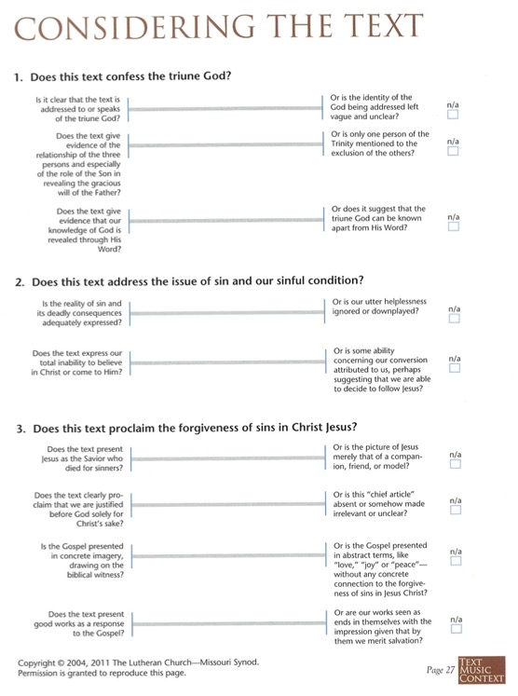
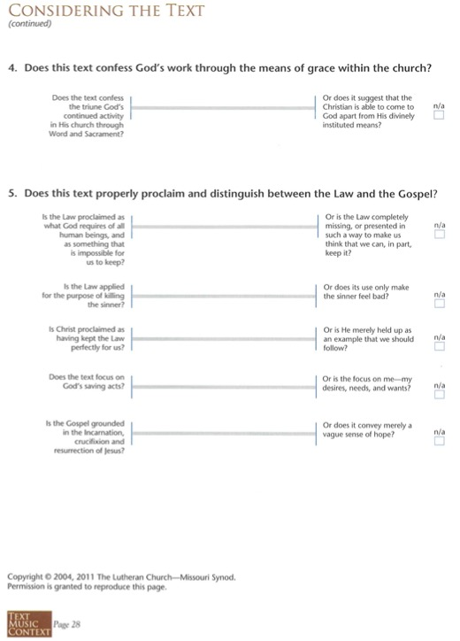
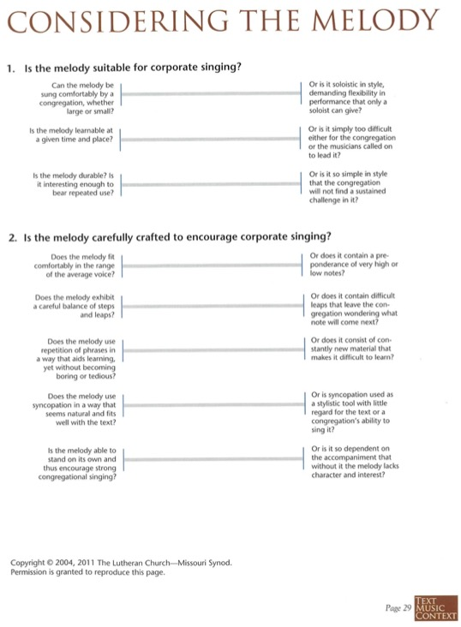
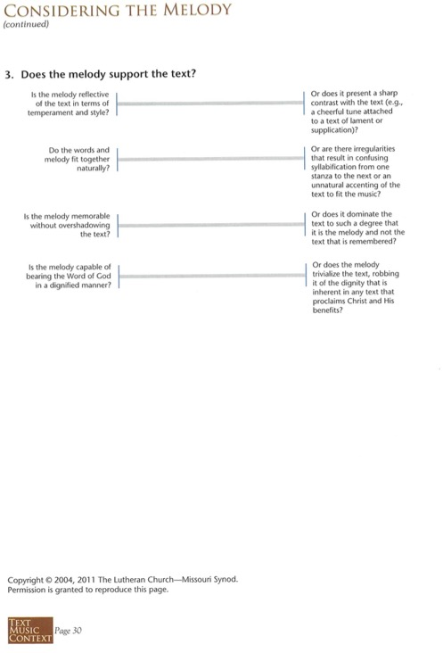
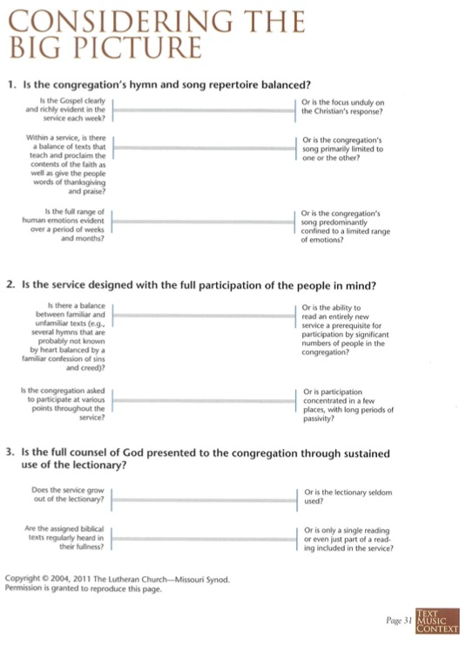
Appendix 4: Praise Song Cruncher

1. Jesus
“Is Jesus mentioned?”
Yes | No If yes, is it in name or concept?
2. Clarity
Is the song clear? Does it use sentences (with subject, verb, object) or sentence fragments?
Very clear 10 9 8 7 6 5 4 3 2 1 Obscure
3. Mysticism (Subjectivity vs Objectivity)
Is the song about the things that God has done (objective), or about my own emotions and experiences (subjective)? Does the song repeat the same phrases over and over in an hypnotic mantra?
Objective 10 9 8 7 6 5 4 3 2 1 Subjective
4. Law and Gospel
Does the song proclaim the law in its sternness and the Gospel in its sweetness? (The Gospel is the promise of the forgiveness of all sins won for us through Jesus’ death on the cross.) Are law and Gospel rightly divided (and not mixed up)? Is the law presented as something that we can do, or does it show us our sins? Is the Gospel conditional (based on my actions, decisions, acceptance)?
Yes No I can’t tell
5. Is there any explicit false teaching?
These five questions, and especially questions two and three help dig up the bones of mysticism.

Keith Getty and Kristyn Getty, Sing!: How Worship Transforms Your Life, Family, and Church (Nashville, TN: B & H publishing group, 2017), 80.
https://www.christianpost.com/news/keith-getty-modern-worship-movement-is-utterly-dangerous-causing-de-christianizing-of-gods-people.html
Horn, Henry. “Hymn (Definition)” in The Development of Lutheran Hymnody in America. (Minneapolis, MN: Augsburg Publishing House, 1967), 6.
Horn, 6.
https://artistictheologian.com/2024/05/06/wrath-in-worship-an-analysis-of-the-wrath-of-god-controversy-surrounding-getty-and-townends-in-christ-alone/
http://secondnaturejournal.com/the-imminent-decline-of-contemporary-worship-music-eight-reasons/
Cosper, Mike. Rhythms of Grace: How the Church’s Worship Tells the Story of the Gospel. (Wheaton, IL: Crossway, 2013), 208.
Cosper, 209.
Cosper, 211.
Cosper, 212.
https://www.christianworship.com/articles/2019/5/18/searching-for-modern-music-for-the-new-hymnal
https://wolfmueller.co/the-praise-song-cruncher/?fbclid=IwZXh0bgNhZW0CMTEAAR2MFT-m6wCZ2govv5LLHAr758tXxZhlVMFhypdSnipkq8d5j2lh9DIfiy8_aem_AV-8deKAeG-a6HGMjC6a5F3A2ywuAbK488p5JA8kOJl35EkZYzJqrqwG1UDS453gZqam4iPd9YVzNfrtU0R0vL0-

